**Assignment Of JAVA**



**Submitted To:** **Submitted By**

Dr. Gopal Singh Deepak

**Roll No:** 21149

**Q.1) Write a Program in which you will declare a default method in base class and use that method in child class in the same package.**

Package Q1;

class a{

void aa()

{

System.out.println("Deepak");

}

}

Package Q1;

class deepak extends a

{

public static void main(String args[])

{

deepak d_149 = new deepak();

d_149.aa();

}

}

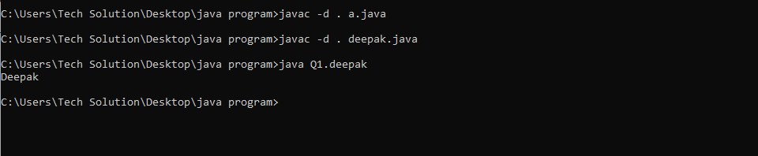

**Q.2) Write a Program in which you will declare and use the default method in the same class.**

class Deepak{

void display()

{

System.out.println("Deepak ");

}

void print()

{

System.out.println("roll no=21149");

}

public static void main(String args[])

{

Deepak d_149 = new Deepak();

d_149.display();

d_149.print();

}

}

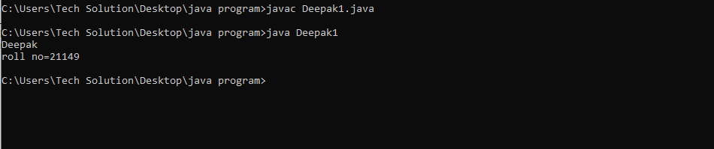

**Q.3) Write a Program in which you will declare a default method in a class and use that method in a non-child class of the same package.**

package q3;

class c

{

void print()

{

System.out.println("Deepak");

}

}

package q3;

class deepak2

{

void display()

{

c mca = new c();

mca.print();

}

public static void main (String args [])

{

deepak2 d_149 = new deepak2();

d_149.display();

}

}

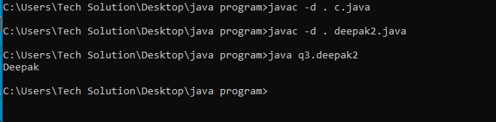

**Q.4) Write a Program in which you will declare a default method in the base class of a different package and use that method in the child class of a different package.**

***Package:-***

package p1;

public class a

{

void print()

{

System.out.println("Deepak");

}

public void show()

{

print();

}

}

***Main Class:-***

package p2;

import p1.a;

class deepak3 extends a

{

void display()

{

a mca = new a();

mca.show();

}

public static void main (String args[])

{

deepak3 d_149 = new deepak();

d_149.display();

}

}

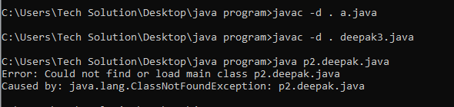

**Q.5) Write a Program in which you will declare a default method in a class of a different package and use that method in a class which is located in a different package.**

***Package:-***

package p1;

public class a

{

void print()

{

System.out.println("Deepak");

}

public void show()

{

print();

}

}

***Main Class:-***

import p1.a;

class deepak

{

void display()

{

a mca = new a();

mca.show();

}

public static void main (String args[])

{

deepak d_149 = new deepak();

d_149.display();

}

}



**Q.6) Write a Program in which you will declare a private method in base class and use that method in child class in the same package.**

package mca;

class e

{

private void print()

{

System.out.println("Deepak");

}

void display()

{

e mca = new e();

mca.print();

}

}

package mca;

class deepak4 extends a

{

public static void main (String args [])

{

deepak4 d_149 = new deepak();

d_149.display();

}

}

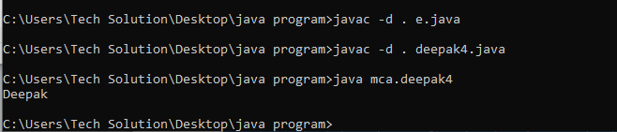

**Q.7) Write a Program in which you will declare and use private methods in the same class.**

package m;

class deepak5

{

private void print()

{

System.out.println("Deepak");

}

public static void main (String args[])

{

deepak5 d_149 = new deepak5();

d_149.print();

}

}

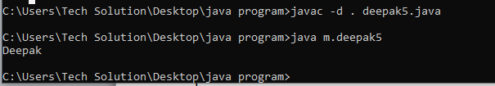

**Q.8) Write a Program in which you will declare a private method in a class and use that method in a non-child class of the same package.**

package c;

class deepak6

{

private void print()

{

System.out.println("Deepak");

}

class deepak7

{

public static void main (String args [])

{

deepak6 d_149 = new deepak6();

d_149.show();

}

}

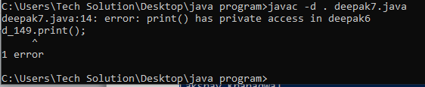

**Q.9) Write a Program in which you will declare a private method in the base class of a different package and use that method in the child class of a different package.**

***Package:-***

package p3;

public class f

{

private void print()

{

System.out.println("Deepak");

}

public void display()

{

a mca = new a();

mca.print();

}

}

***Main Class:-***

package p4;

import p3.a;

class deepak8 extends f

{

void show()

{

f mca = new f();

mca.display();

}

public static void main (String args [])

{

deepak8 d_149 = new deepak8();

d_149.show();

}

}

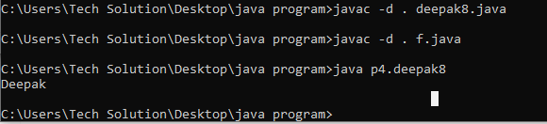

**Q.10) Write a Program in which you will declare a private method in a class of a different package and use that method in a class which is located in a different package.**

***Package:-***

package p5;

public class g

{

private void print()

{

System.out.println("Deepak");

}

}

***Main Class:-***

package p6;

import p5.g;

public class deepak9

{

public static void main (String args [])

{

deepak9 d_149 = new deepak9();

d_149.print();

}

}

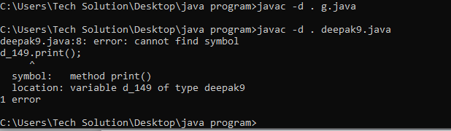

**Q.11) Write a Program in which you will declare a protected method in base class and use that method in child class in the same package.**

package p6;

class h

{

protected void print()

{

System.out.println("Deepak");

}

}

class deepak12 extends h

{

void display()

{

h mca = new h();

mca.print();

}

public static void main (String args [])

{

deepak12 d_149 = new deepak12();

d_149.display();

}

}

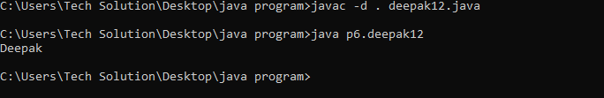

**Q.12) Write a Program in which you will declare and use protected method in the same class.**

class deepak13

{

protected void print()

{

System.out.println("Deepak");

}

public static void main (String args [])

{

deepak13 d_149 = new deepak13();

d_149.print();

}

}

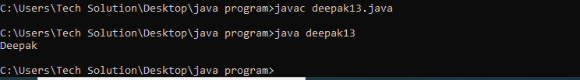

**Q.13) Write a Program in which you will declare a protected method in a class and use that method in a non-child class of the same package.**

package j;

class deepak14

{

protected void print()

{

System.out.println("Deepak");

}

}

class deepak15

{

void display()

{

deepak14 mca = new deepak14();

mca.print();

}

public static void main (String args [])

{

deepak15 d_149 = new deepak15();

d_149.display();

}

}

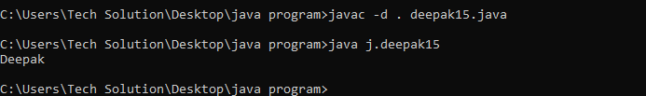

**Q.14) Write a Program in which you will declare a protected method in the base class of a different package and use that method in the child class of a different package.**

***Package:-***

package k;

class deepak16

{

protected void print()

{

System.out.println("Deepak");

}

}

***Main Class:-***

package l;

import k.deepak16;

class deepak17 extends deepak16

{

public static void main (String args [])

{

deepak17 d_149 = new deepak17();

d_149.display();

}

}

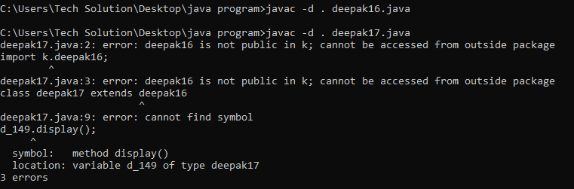

**Q.15) Write a Program in which you will declare a protected method in a class of a different package and use that method in a class which is located in a different package.**

***Package:-***

package r;

public class n

{

protected void print()

{

System.out.println("Deepak");

}

}

***Main Class:-***

package s;

import p1.n;

class deepak18

{

public static void main (String args [])

{

deepak18 d_149 = new deepak18();

d_149.show();

}

}

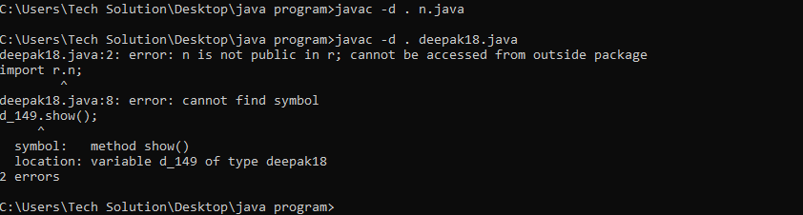

**Q.16) Write a Program in which you will declare a public method in base class and use that method in child class in the same package.**

package shiv;

class a

{

public void print()

{

System.out.println("Deepak");

}

}

class deepak19 extends a

{

public static void main (String args [])

{

deepak19 d_149 = new deepak19();

d_149.print();

}

}

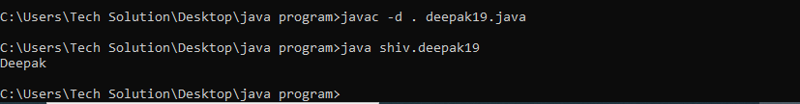

**Q.17) Write a Program in which you will declare and use a public method in the same class.**

package hanumanji;

class deepak20

{

public void print()

{

System.out.println("Deepak");

}

public static void main (String args[])

{

deepak20 d_149 = new deepak20();

d_149.print();

}

}

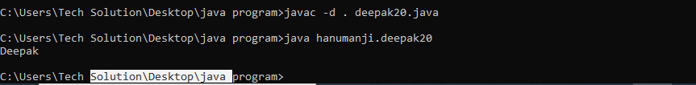

**Q.18) Write a Program in which you will declare a public method in a class and use that method in a non-child class of the same package.**

package z;

class x

{

public void print()

{

System.out.println("Deepak");

}

}

class deepak21

{

public static void main (String args [])

{

deepak21 d_149 = new deepak21();

d_149.print();

}

}

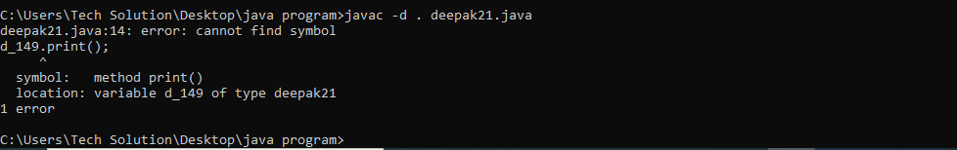

**Q.19) Write a Program in which you will declare a public method in the base class of a different package and use that method in the child class of a different package.**

***Package:-***

package p1;

public class a

{

public void print()

{

System.out.println("Deepak");

}

}

***Main Class:-***

package p2;

import p1.a;

class deepak extends a

{

public static void main (String args [])

{

deepak d_149 = new deepak();

d_149.print();

}

}

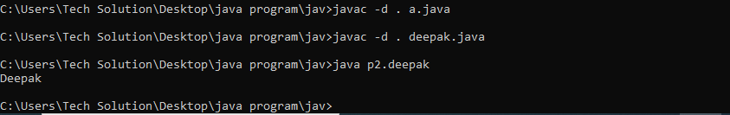

**Q.20) Write a Program in which you will declare a public method in a class of a different package and use that method in a class which is located in a different package.**

***Package:-***

package p1;

public class a

{

public void print()

{

System.out.println("Deepak");

}

}

***Main Class:-***

Package p2;

import p1.a;

class deepak

{

public static void main (String args [])

{

deepak d_149 = new deepak();

d_149.display();

}

}

